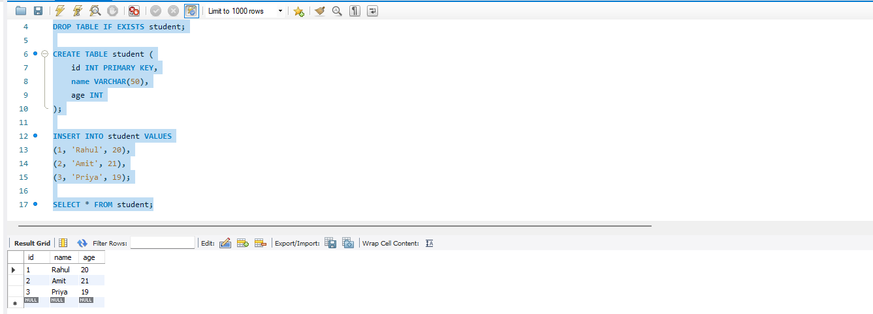
DATE:-1-JUNE-2026
CREATE DATABASE IF NOT EXISTS test;
USE test;

DROP TABLE IF EXISTS student;

CREATE TABLE student (
id INT PRIMARY KEY,
name VARCHAR(50),
age INT
);

INSERT INTO student VALUES
(1, 'Rahul', 20),
(2, 'Amit', 21),
(3, 'Priya', 19);

SELECT * FROM student;
package mongo;

import java.sql.*;

public class Testing1 {

public static void main(String[] args) {

try {
Class.forName("com.mysql.cj.jdbc.Driver");

Connection con = DriverManager.getConnection(
"jdbc:mysql://localhost:3306/test",
"root",
"1234"
);

Statement stmt = con.createStatement();

ResultSet rs = stmt.executeQuery("SELECT * FROM student");

while (rs.next()) {
System.out.println(
rs.getInt(1) + " " +
rs.getString(2) + " " +
rs.getInt(3)
);
}

con.close();

} catch (Exception e) {
e.printStackTrace();
}
 


